Region duplication detection using color histogram and moments in digital image

Abstract— Region duplication or copy move forgery is a common type of tampering scheme carried out to create a fake image. The field on blind image forensics depends upon the authenticity of the digital image. As in copy move forgery the duplicated region belongs to the same image, the detection of tampering is complex as it does not leave a visual clue. But the tampering gives rise to glitches at pixel level. In the proposed work, we use the feature extraction method which emphasizes on the color content of the forged image. To explore on the color contents of the forged image, HSV Color space and color moments of the tampered image is analyzed. The proposed method works effectively on two different databases and the experimental results shows significant accuracy in detection of the forged region. The scheme is also successful in detection of forgery for images which are subjected to transformation and also effectively detects multiple copy move forgery attacks.

Keywords—copy-move forgery detection, HSV Histogram, feature extraction, blind image forensic.
- INTRODUCTION
In recent years technology is flourishing extensively in every field. Digital photography is at its boom. The glamour industry, news media, medical field, legal evidences, forensics are all excessively influenced by these tremendous changes in the digital image processing field. With today’s sophisticated devices available in the market and numerous photo editing software packages, the authenticity of a digital image has become challenging. A digital image may be manipulated in various ways. The image contrast or the brightness may be changed. The object from the image can be removed, or an object may be added to the image. Two images can be spliced together to enhance the image content [1].



Figure 1. Doctored Image and Real image respectively

Various kind of doctored images are floated on social networking sites and smartphone applications. The features, color tone, texture are manipulated by easily available photo- editing software’s on cellphones, to enhance a normal captured picture. Fig. 1 shows an example of doctored image. It is a simple example of adding an object and retouching to enhance the original picture.
The paper lays emphasis on a forgery which is extensively used for tampering the image. This manipulation is referred to as copy move forgery. In copy-move kind of tampering a region is copied from the image and attached in the image. This is in general carried out to hide a specific unwanted object in the image as shown in fig. 2 or to enrich the innards of the image as in fig 3.

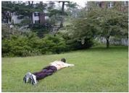
Figure 2. Original Image and Forged image respectively

Fig. 2 depicts hiding of unwanted object from the image; here a patch from the lawn is copied and pasted on the man lying on the lawn.

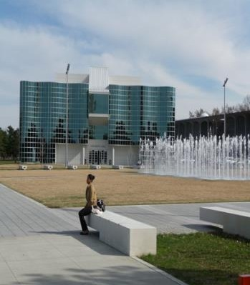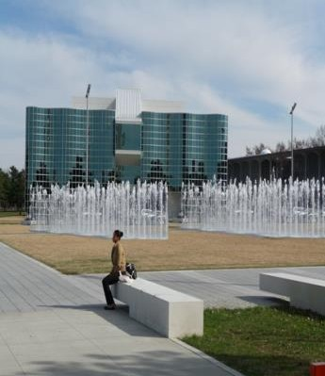
Figure 3. Original Image and Forged image respectively

Fig. 3 depicts enriching the contents of the image, here the water fountain is copied and pasted in the vacant region of the same image to augment the fillings of the image.
It is apparent that the fiddling done to both the images is not evident to our eyes. Many a times, while pasting, the copied region is retouched to blend along with the surroundings of the image. Though untraced by human eyes, the forgery does create abnormalities in image statistics at pixel level. Therefore detection of this forgery becomes plausible by exploring the changes in the pixel statistics of the image. The detection schemes employed for copy move forgery are thus referred to as pixel based approach.
Different algorithms and procedures are developed by researchers, which differ in the segmentation format, feature extraction, match detection process. The methods depending on segmentation were categorized as block and keypoint based. Fridrich et al. [2] in block based method preprocess the image into grayscale before dividing the colored image into overlapping blocks, and then computing the DCT coefficients of the blocks which are arranged lexicographically for finding a match. Popescu and H. Farid [3], unlike Fridrich implemented feature extraction by PCA. The scheme proved successful in detection of forgery of cloned portion.
Representation of image in reduce dimension was presented by [4], and [5] , where DWT of image was obtained wherein SVD was implemented by [4] and log polar coordinates and phase correlation along with exhaustive search was executed by [5] for identifying a match. The query image is disintegrated into LL1 and HH1 subbands and divided into blocks using DyWT in method proposed by G. Muhammad et al. [10]. Here, sorting is based on likeness and variation using approximation and detail subbands respectively.
SIFT [6],[9]and SURF[8] are categorized as keypoints based methods which focus on high entropy sections in the image to extract features. These methods, though complex are efficient in detection of copy-move forgery in event of rotation scaling and translation. Jing-Ming Guo et al. [11] detection method uses daisy descriptor with ANMS for matching keypoints, which aids rotation invariant detection. S. Bayram,
H. Sencar, and N. Memon [7], and Leida Li et al. [13] employed the FMT and Polar Harmonic Transforms respectively on the image. Unlike the traditional methods which divided the image in blocks, [13] carried out the feature extraction on circular blocks and duplicated region was identified on post processing the similar blocks.
Feature extraction by computing histogram of Gabor magnitude obtained by applying Gabor filter to image blocks was recently proposed by Chen-Ming Hsu et al. [14]. Further similar matches are detected by sorting and post processing. Cheng-Shian Lin et al. [15], proposed scheme that reduced the time complexity by improvised cluster expanding block algorithm for copy-move forgery detection.

- PROPOSED METHODOLOGY


Forged Image
Divide image
Feature extraction
Duplication detection
Match Features
Duplication detection

HSV
Histogram
Match Features

Color Moments


Forgery Detection
Similarity Measure

Figure 4. Architecture of proposed scheme

The input query image is the forged image. The image is divided into blocks. On dividing the image into blocks, each block is subjected to transformations. Features are extracted from each block. And on basis of the similarity measures the forgery is detected. The forgery to be untraceable by the viewer, the copied region is also sometimes flipped or rotated before pasting, extracting features from the blocks subjected to transformations, aids the detection of forgery accurately.
- HSV Histogram
The CBIR systems widely analyse the color histograms. Although it does not give the spatial position of each color, it defines the magnitudes of different colors in the image. A relational representation of RGB color space is given by HSV color space, which provides computational ease. HSV color space can be analysed for pictorial insight of difference in H, S and Intensity values of Image pixel. Based on pixel saturation value, and taking Hue or intensity as dominant attribute, features are extracted. The HSV histogram is obtained for each image block. Here the image is divided into H, S, V plane and each plane is quantised, by specifying values of quantization levels. The maximum of H, S and V are obtained to create final histogram and then it is further normalized.
- Color Moments
Color feature vector derived from the analysis of RGB color space, generally called color moment, and comparatively more stable and insensitive to rotation and zoom of image. Images can be segregated on basis of the features of the color, which can be determined by the color moments. Probability distribution, which is described or defined by distinctive moments, can be related to the color dissemination in an image. It therefore follows that if the color in an image follows a certain probability distribution, the moments of that distribution can then be used as features to identify that image based on color. Extracting the 3 color channels, the first two moments are computed.
The average and variance for i^{th} color channel are defined as follows:

The figure 3 gives the architecture of the proposed methodology.
1 M
i M j=1 ij
µ = ∑ ƒ
(1)

o = J1 ∑^{M}

(ƒij − o )2
(2)

i M j=1 i

The standard deviation is the square root of the variance.
- Similarity Measure for detection of forgery
On extracting the features, they are sorted into a matrix. Every block feature is arranged in the row of matrix. Now a comparison between features of concerning block with features of all other block is required to obtain a match. The similarity measure used is the L1 norm also referred to as Manhattan Distance. It gives the sum of absolute difference between the feature vectors. It is articulated as follows,



Figure 6. The first image is subjected to multiple cloning attacks, and the second image shows the detection using HSV histogram.

Manℎattandict(p, q) = ∑^{n}
|pi − qi|
(3)
The figure 7 and 8 represents the performance assessment

i=1

- RESULT AND DISCUSSION
The detection scheme is implemented on two databases viz. the CoMoFoD [12] database and MICC-F [9] database. Both the database has multiple types of copy-move forged images and original images. Figure 5 depicts tampering detection for image where the cloned region is rotated at a particular angle in each image.



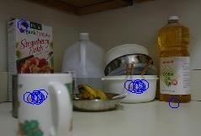

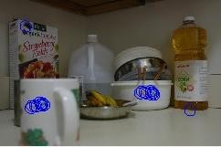
  - Forged Image b. Forgery Detection

Figure 5. Forged images under ‘a’ indicates the duplicated region been rotated at few degree, while the efficient detection of the forged region using color moments for feature extraction is illustrated in images under ‘b’

Figure 6 depicts detection of multiple duplication attacks in the same image by exploring the HSV Color space.
in terms of precision parameter which is calculated on basis of true and false positive images. The proposed scheme is implemented on selected images of CoMoFoD and MICC_F database referred as DB1and DB2 respectively. Figure 9 portrays a relative analysis with other detection methods on basis of F1 score.

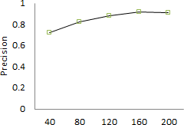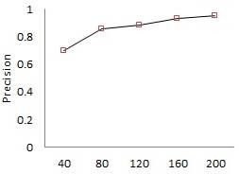
No. of Samples No. of Samples
Figure 7. Results for DB1,using HSV and Color Moments respectively

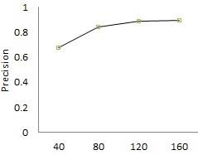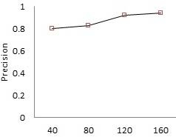
No. of Samples No. of Samples
Figure 8. Results for DB2,using HSV and Color Moments respectively
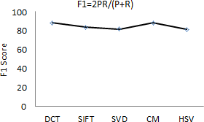

Figure 9. Evaluation chart on basis of F1, where P denotes Precision and R denotes recall.

- CONCLUSION
Copy-Move forgery is a tampering which is commonly practiced and can go undetected. The problem itself is very interesting. In this scheme we present a proficient method to identify the region duplication. The color moments derived are robust to rotation of copied region to any degree and also detects forgery on event of scaling. The HSV Histogram based extracted features successfully detects multiple duplicated region in the image. The proposed system is less intricate and robust to affine transformations. The forensic technique in future can be explored for different kind of tampering such as splicing two images from the database.
REFERENCES

- Hany Farid ‘Image Forgery Detection A survey’ IEEE Signal Processing Magazine march 2009, Digital Object Identifier 10.1109/MSP.2008.931079 available on www.cs.dartmouth.edu
- J. Fridrich, D. Soukal, and J. Luk´a.s, “Detection of copy-move forgery in digital images,” in Proceedings of Digital Forensic Research Workshop, Aug. 2003
- Popescu and H. Farid, “Exposing digital forgeries by detecting duplicated image regions,” Department of Computer Science, Dartmouth College, Tech. Rep. TR2004-515, 2004. Also available on
- G. Li, Q. Wu, D. Tu, and S. Sun, “A Sorted Neighborhood Approach for Detecting Duplicated Regions in Image Forgeries Based on DWT and SVD,” in IEEE International Conference on Multimedia and Expo, Jul. 2007, pp. 1750–1753.
- Myna, M. G. Venkateshmurthy, and C. G. Patil, “Detection of Region Duplication Forgery in Digital Images Using Wavelets and Log-Polar Mapping,” in IEEE International Conference on Computational Intelligence and Multimedia Applications, Dec. 2007, pp. 371–377.
- H. Huang, W. Guo, and Y. Zhang, “Detection of Copy-Move Forgery in Digital Images Using SIFT Algorithm,” in Pacific-Asia Workshop on Computational Intelligence and Industrial Application, vol. 2, Dec. 2008, pp. 272–276.
- S. Bayram, H. Sencar, and N. Memon, “An efficient and robust method for detecting copy-move forgery,” in IEEE International Conference on Acoustics, Speech, and Signal Processing, Apr. 2009, pp. 1053–1056.
- L. Shivakumar and S. Baboo, “Detection of Region Duplication Forgery in Digital Images Using SURF,” International Journal of Computer Science Issues, vol. 8, no. 4, pp. 199–205, 2011.
- I. Amerini, L. Ballan, R. Caldelli, A. Del Bimbo, G. Serra. “A SIFT- based forensic method for copy-move attack detection and transformation recovery”, IEEE Transactions on Information Forensics and Security, vol. 6, iss. 3, pp. 1099-1110, 2011
- Muhammad, Ghulam Hussain, Muhammad Bebis, “GeorgePassive copy move image forgery detection using undecimated dyadic wavelet transform”, Digital Investigation 9 (2012) 49–57
- Jing Ming Guo, Yun-Fu Liu, Zong-Jhe Wu, “Duplication forgery detection using improved DAISY descriptor “ in Elsevier International Journal - Expert Systems with Applications 40 (2013) 707–714
- Tralic D., Zupancic I., Grgic S., Grgic M., "CoMoFoD - New Database for Copy-Move Forgery Detection", in Proc. 55th International Symposium ELMAR-2013, pp. 49-54, September 2013
- Leida Li, Shushang Li , Hancheng Zhua, Xiaoyue Wub “Detecting copy- move forgery under affine transforms for image forensics” Computers and Electrical Engineering, 40 (2014) 1951–1962
- Chen-Ming Hsu , Chungli, Taiwan, Jen-Chun Lee and Wei-Kuei Chen, “An Efficient Detection Algorithm for Copy-Move Forgery” in 10th sia Joint Conference on Information Security, pp 33-36, May 2015
- Cheng-Shian Lin , Chien-Chang Chen and Yi-Cheng Chang “An Efficiency Enhanced Cluster Expanding Block Algorithm for Copy- Move Forgery Detection” in International Conference on Intelligent Networking and Collaborative Systems (INCOS),Sept 2015 , pp. 228 – 231.

